**Practical No. 01**

**AIM:-** write a program in java to demonstrate java programing structure.

class structure

{

public static void main(String[] args)

{

System.out.println("simple java structure");

}

}

**Output:-**



**Practical No. 02**

**AIM:-** write a program in java to get the input from user and print the variable value.

import java.util.Scanner;

class variable

{

public static void main(String[] args)

{

int a;

Scanner value=new Scanner(System.in);

System.out.println("enter the value of a:");

a=value.nextInt();

System.out.println(+a);

}

}

**Output:**-



**Practical No. 03**

**AIM:-** write a program in java to print the value of different data type

class variable2

{

public static void main(String a[])

{

int d;

char b;

float c;

d= 5;

b= 'k';

c= 1.234f;

System.out.println("value of d:"+d);

System.out.println("value of b:"+b);

System.out.println("value of c:"+c);

}

}

**Output:-**

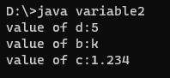

**Practical No. 04**

**AIM:-** write a program in java to, demonstrate use of scope resolution operator.

import java.util.Scanner;

class scope

{

static int x = 5;

public static void main(String a[])

{

int z = 10;

System.out.println("this is local variable:" +z);

System.out.println("this is global variable:"+scope.x);

}

}

**Output:-**

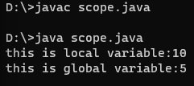

**Practical No. 05**

**AIM:-** write a program in java to perform arithmetic operation .

class s

{

public static void main(String a[])

{

int num1=20,num2=10,add,mul,div,sub;

System.out.println("num1="+num1);

System.out.println("num2="+num2);

add=num1+num2;

sub=num1-num2;

mul=num1*num2;

div=num1/num2;

System.out.println("addition:"+add);

System.out.println("substraction:"+sub);

System.out.println("divition:"+div);

System.out.println("multiplication:"+mul);

}

}

**Output:-**

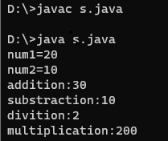

**Practical No 06**

**AIM:-** write a program in java to, perform logical operator .

import java.util.Scanner;

class mark

{

public static void main(String a[])

{

int m;

Scanner s=new Scanner(System.in);

System.out.println("enter your mark");

m=s.nextInt();

if(m>=60 && m<=90)

{

System.out.println("grade A");

}

else if(m>=45 || m<=59)

{

System.out.println("grade B");

}

else if(m>=30 || m<=44)

{

System.out.println("grade C");

}

else {

System.out.println("fail"); } } }

**Output:-**

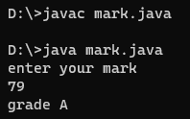

**Practical No. 07**

**AIM:-** write a program in java to check you are eligible for voting or not using conditional operator.

import java.util.Scanner;

class voting

{

public static void main(String a[])

{

int x;

Scanner vot=new Scanner(System.in);

System.out.println("enter your age");

x=vot.nextInt();

String eligible=(x>=18) ?" i am eligible":"i am not eligible";

System.out.println(eligible);

}

}

**Output:-**

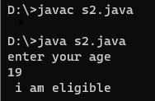

**Practical No. 08**

**AIM:-** write a program in java to, check pass and fail using if……else statement.

import java.util.Scanner;

class rusult

{

public static void main(String a[])

{

int mark;

Scanner x=new Scanner(System.in);

System.out.println("enter your mark");

mark=x.nextInt();

if(mark>=30)

{

System.out.println("i am pass");

}

else

{

System.out.println("i am fail");

}

}

}

**Output:-**

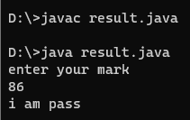

**Practical No. 09**

**AIM:-** write a program in java to, check grade mark you get in exam using ladder if….else.

import java.util.Scanner;

class mark

{

public static void main(String a[])

{

int m;

Scanner s=new Scanner(System.in);

System.out.println("enter your mark");

m=s.nextInt();

if(m>=60 && m<=90)

{

System.out.println("grade A");

} else if(m>=30 && m<=59)

{

System.out.println("grade B");

} else if(m>=30 && m<=44)

{

System.out.println("grade C");

} else

{

System.out.println("fail"); } } }

**Output:-**

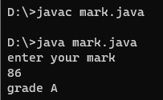

**Practical No. 10**

**AIM:-** write a program in java to, count number from 1 to 10 using for loop.

import java.util.Scanner;

class number

{

public static void main(String a[])

{

int n=10,i;

System.out.println("number from 1 to 10:");

for(i=1;i<=n;i++)

{

System.out.println(+i);

}

}

}

**Output:-**

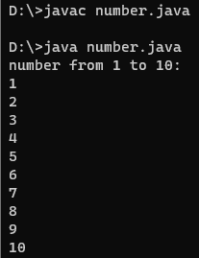

**Practical No. 11**

**AIM:-** write a program in java to, print even number from 10 to 20 using while loop.

import java.util.Scanner;

class member

{

public static void main(String a[])

{

int n;

Scanner x=new Scanner(System.in);

System.out.println("enter the value of n:");

n=x.nextInt();

int i=9;

while(i<=n)

{

i++;

System.out.println(i);

i++;

}

}

}

**Output:-**

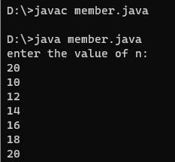

**Practical No. 12**

**AIM:-** write a program in java to, demonstrate continue statement.

import java.util.Scanner;

class ciquance

{

public static void main(String a[])

{

int b;

Scanner scn=new Scanner(System.in);

System.out.println("emter number you want");

b=scn.nextInt();

System.out.println("number print between 20 to 35:");

for(int i=20;i<=b;i++)

{

if(i==25)

{

continue;

}

System.out.println(i);

} } }

**Output:-**

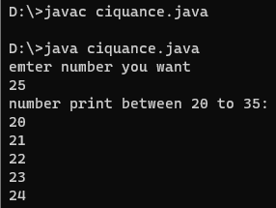

**Practical No. 13**

**AIM:-** write a program in java to, break statement .

import java.util.Scanner;

class ciquance

{

public static void main(String a[])

{

int b;

Scanner scn=new Scanner(System.in);

System.out.println("emter number you want");

b=scn.nextInt();

System.out.println("number print between 20 to 35:");

for(int i=20;i<=b;i++)

{

if(i>=35)

{

break; }

System.out.println(i); } } }

**Output:-**

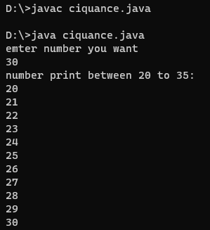

**Practical No. 14**

**AIM:-** write a program in java to, class, method and object .

import java.util.Scanner;

class student1

{

int roll;

int age;

float fee;

void getdata()

{

Scanner b=new Scanner(System.in);

System.out.println("enter your roll no:");

roll=b.nextInt();

System.out.println("enter your age:");

age=b.nextInt();

System.out.println("enter your fee:");

fee=b.nextFloat();

System.out.println("******************");

System.out.println("my roll no is:"+roll);

System.out.println("my name is:"+age);

System.out.println("my fee is:"+fee);

}

public static void main(String a[])

{

student1 s=new student1();

s.getdata();

}

}

**Output:-**

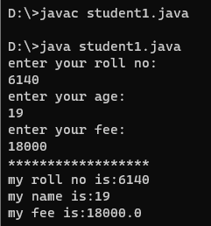

**Practical No. 15**

**AIM**:- write a program in java to, initialize the value of one dimensional array .

class array

{

public static void main(String args[])

{

int a[]={};

a[0]=10;

a[1]=20;

a[2]=30;

a[3]=40;

a[4]=50;

System.out.println(+a[0]);

System.out.println(+a[1]);

System.out.println(+a[2]);

System.out.println(+a[3]);

System.out.println(+a[4]);

}

}

**Output:-**

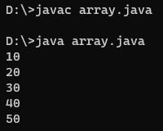

**Practical No. 16**

**AIM:-** write a program in java to, initialize the value of two dimensional array .

import java.util.Scanner;

class Main {

public static void main(String[] args)

{

Scanner scan = new Scanner(System.in);

System.out.print("Enter number of rows: ");

int rows = scan.nextInt();

System.out.print("Enter number of columns: ");

int columns = scan.nextInt();

int[][] multidimensionalArray= new int[rows][columns];

for (int i = 0; i < rows; i++) {

for (int j = 0; j < columns; j++) {

multidimensionalArray[i][j]= (i + 1) * (j + 1);

}

}

for (int i = 0; i < rows; i++) {

for (int j = 0; j < columns; j++) {

System.out.print(multidimensionalArray[i][j]+ " ");

}

System.out.println(); }

scan.close(); } }

**Output:-**

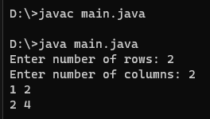

**Practical no 17**

**AIM:-** write a program in java to, demonstrate different type of inheritance.

1. **Single inheritance:-**

class bcs

{

void first()

{

System.out.println("i am bcs sy student");

}

}

class bca extends bcs

{

void second()

{

System.out.print("i am bca sy student");

}

public static void main(String a[])

{

bca obj=new bca();

obj.first();

obj.second();

}

}

**Output:-**

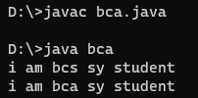

1. **Multi _level inheritance:-**

class student

{

void first()

{

System.out.println("i am bcs student");

}

}

class bcs extends student

{

void second()

{

System.out.println("i am bcs sy student");

}

}

class bca extends bcs

{

void third()

{

System.out.println("i am bca sy student");

}

public static void main(String a[])

{

bca obj=new bca();

obj.first();

obj.second();

obj.third();

}

}

**Output:-**

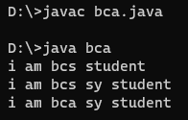

1. **Hierarchical inheritance:-**

class grand

{

void first()

{

System.out.println("i am grand father");

}

}

class father extends grand

{

void second()

{

System.out.println("i am father");

}

}

class son extends grand

{

void third()

{

System.out.println("i am son");

}

}

class daughter

{

public static void main(String a[])

{

father p=new father();

p.first();

p.second();

son obj=new son();

obj.first();

obj.third();

}

}

**Output:-**

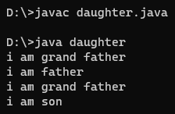

**Practical no 18**

**AIM:-**  write a program in java to, demonstrate final veriable ,method and final class .

1. **Final variable:-**

class bike

{

final int speed=90;

void run()

{

speed=400;

}

public static void main(String a[])

{

bike obj=new bike();

obj.run();

}

}

**Output:-**

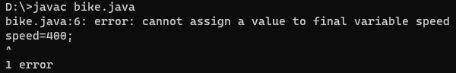

1. **Final method:-**

class bike

{

final void run()

{

System.out.println("this is final method");

}

}

class honda extends bike

{

void run()

{

System.out.print("this is second method");

}

public static void main(String a[])

{

honda obj=new honda();

obj.run();

}

}

**Output:-**

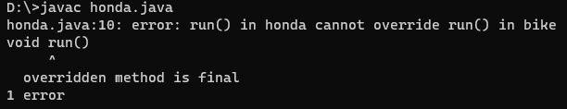

1. **Final class:-**

final class bike

{

}

class honda2 extends bike

{

void run()

{

System.out.print("this is final class");

}

public static void main(String a[])

{

honda2 obj=new honda2();

obj.run();

}

}

**Output:-**

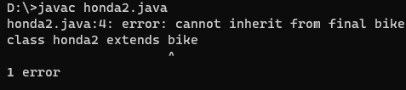

**Practical no 19**

**AIM:-** write a program in java to, demonstrate defining and implementing interface.

interface face

{

void display();

}

class inter implements face

{

public void display()

{

System.out.print("this is interface");

}

public static void main(String a[])

{

inter obj=new inter();

obj.display();

}

}

**Output:-**

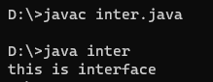

**Practical no 20**

**AIM:-** write a program in java to, demonstrate creating and accessing package .

package pack;

public class strong

{

public static void main(String a[])

{

System.out.print("this is package statement ");

}

}

**Output:-**

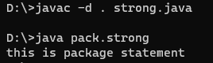

**Practical no 21**

**AIM:-** write a program in java to, demonstrate concept of exception.

class javaexception

{

public static void main(String a[])

{

try {

int data=100%0;

}

catch(ArithmeticException e)

{

System.out.println(e);

}

System.out.println("code is stop");

}

}

**Output:-**

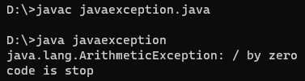

**Practical no 22**

**AIM:-** write a program in java to, demonstrate different string classes .

class stringexample

{

public static void main(String a[])

{

String s1=new String("java");

String s2=new String("program");

System.out.println(s1);

System.out.println(s2);

}

}

**Output:-**

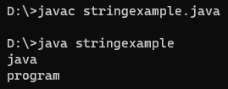

**Practical no 23**

**AIM:-** write a program in java to, demonstrate concept of applet.

## import java.awt.*;

## import java.applet.*;

## public class Simple extends Applet

{

## public voidpaint(Graphics g)

## {

## g.drawString("A simple Applet", 20, 20);

## }

## }

## **Output:-**

## 

**Practical no 24**

**AIM:-** write a program in java to, demonstrate reading from and writing in to the files.

1. **Writing file:-**

import java.io.FileWriter;

import java.io.IOException;

class write

{

public static void main(String[] args) throws IOException

{

String str = "this is filewriting program.";

FileWriter obj=new FileWriter("output.txt");

for (int i = 0; i < str.length(); i++)

obj.write(str.charAt(i));

System.out.println("file is created:");

obj.close();

}

}

**Output:-**

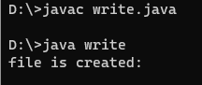

1. **Reade file:-**

import java.io.*;

public class FileRead {

public static void main(String[] args) {

try (FileReader r = new FileReader("D:/VS Code/java/output.txt"))

{

int i;

while ((i = r.read()) != -1) {

System.out.print((char) i);

}

} catch (IOException e) {

System.out.println("file is reded:");

}

}

}

**Output:-**

